GSAP_eCustoms_MIC

Version: 1
Status: Initial Draft
Prepared By: Praveen C V
Last Updated On: May 21, 2009

Document Information

Deliverable Name | Functional Specification GSAP_eCustome_MIC.doc
Author | Praveen C.V
Owner | Pramod Prasanth
Team
Source Application Owner | Frederique Serrano
Source Application technical contact | Sajith Hari
Target Application Owner | Anibass Stefan
Target Application technical contact | Anibass Stefan
Status | Initial Draft
Version

Document Review & Sign-off

Signatories
Role | Name | Signature | Date
IS Lead

Reviewers
Role | Name | Comments Received | Date
Source Application technical contact | Sajith Hari
Target Application technical contact | Anibass Stefan

Revision History

Version No. | Date | Author | Revision Description
0.0 | 21/05/09 | Praveen C.V | Initial Draft
1.0 | 27/05/09 | Praveen C.V | Incorporated all the review comments form Rajesh Shanmugasundaram
1.1 | 29/05/09 | Rajesh.S | Incorporated all the review comments from Frederique/ Lerch Paramjit
1.2 | 16/06/09 | Praveen C.V | MIC production URL added.
1.3 | 16/09/09 | Praveen C.V | Source structure change details and mapping sheet updated.

Other Related Documents

Related Document | Comment
http://ts1.pro.intra/sites/GLISOASISPI/Restricted_Documents/MIC%20Process%20Description%20syngenta%20v1.3.doc | Syngenta process description.
http://ts1.pro.intra/sites/GLISOASISPI/Restricted_Documents/OASIS_PI_User_Requirement_Specification.xls | User requirement specification.
http://ts1.pro.intra/sites/GLISOASISPI/Restricted_Documents/eCustoms%20BRS%20v0.2.doc | Business Requirment Specification

Table of Contents

1. Sign-off Checklist 5
2. Introduction 6
2.1. Executive Summary 6
2.2. Purpose of this document 6
2.3. Document Structure 6
3. Overview and Scope 7
3.1. Interface Requirement Back ground 7
3.2. Functional Description 7
3.3. Dependencies / Constraints 7
3.4. Assumptions 8
3.5. Document Scope 8
4. Business Process Overview 9
4.1. Current Scenario 9
4.2. To-Be Scenario 9
5. Functional Requirements 10
5.1. Functional Specification 10
5.2. Interface Process Flow Diagram 10
5.3. Security Requirements 10
6. Interface Requirements 11
6.1. System Details and Direction 11
6.2. Transaction Volume 11
6.3. Frequency and Timing 11
6.4. Initiating Process / Transaction / Program 12
6.5. Processing Type 12
6.6. Proposed Transfer Method / Program 12
6.7. Target / Source Data Layout 12
6.8. Mapping SAP fields to Source / Target 12
6.9. Network Integration 12
6.10. Reporting and Monitoring 12
6.11. Error Handling 12
7. SAP Requirements (if applicable) 13
7.1. Selection Screen Details 13
7.2. Transaction Screen Sequence (if no load module exists) 13
7.3. Post Interface Activities 13
7.4. Legacy System Extract/Load Procedure 13
7.5. Security and Authorization 13
7.6. Reconciliation Procedures and Audit Requirements 13
7.6.1. Approach 13
7.6.2. Metrics 13
7.7. Batch Requirements 13
7.8. Data Maintenance Requirements 13
8. Process and Operational Considerations 14
8.1. Performance 14
8.2. Processing Type 14
8.3. Backup and Archiving 14
8.4. Change Management Requirements 14
8.5. Migration Requirements 14
8.6. Reprocessing and double loading requirements 14
8.7. Other 14
9. Testing Requirements 15
9.1. Key Business Test Conditions 15
10. Design Alternatives 16
11. Outstanding Issues 17
12. Appendix 18
12.1. Glossary of Terms 18
12.2. Additional Supporting/Reference Documentation 18

Sign-off Checklist

Use the following checklist to guide your completion of the Functional Design Document.

Standards and Consistency
Has the correct template been used and all sections been completed as required?
Are the correct details (Business Owner for sign-off, status etc) displayed on the front page?
Have all the assumptions been documented properly so that there are no open issues in the document?
Has the document history been continuously updated?

Integration and Dependencies
Have all inputs and outputs been identified and confirmed?
Have all referenced documents been listed (other business process designs, sub process designs, spreadsheets, information papers, etc.)?

Design
Has the report development technique been identified
Has an example of existing RICEF object been included?
If the report is of type modification (custom development), has it been approved?
Have all areas of impact been identified?

Performance
Have the performance implications, metrics and targets been documented?
Has the performance and volume usage of the report development been considered?

Exceptions and Error Handling
Have the exceptions and likely errors been defined and listed?
Does the document describe what steps (if any) need to be taken after an exception has been raised?
Have all the applicable business scenarios been considered, along with the corresponding test conditions?

Usability – From the user perspective
Has the report attempted to maximize the efficiency of the user (i.e. simple to use, intuitive, quick to use)?
Are any manual steps clearly defined and carefully designed?

Flexibility – From a business perspective
Have all steps been clearly identified and documented so new functionality can be added in the future?

Additional information
Has security been considered (e.g. authority checking considered, target group of users who should be given access to the report etc)?
Are the test conditions sufficiently detailed to enable a full test of all required functionality?

Introduction

Executive Summary

The goal of this interface is to make all export declarations for France, UK, Belgium & Switzerland electronically from gSAP system and send it automatically with the MIC-CUST application to the different customs EDI systems of MIC.

Purpose of this document

This document is used to describe the functional design of the interfaces between GSAP and MIC. It aims to give an understanding why the interface is needed and detailed information about the functional requirements.

Document Structure

The document is divided into the following sections:
<Provide a list of the sections here, and add a one line description of the contents>

Overview and Scope

Interface Requirement Back ground

GSAP – MIC

Short description | This interface serves the business and customs declaration relevant data to customs EDI stystem via MIC hub.
Business Area: | Crops |  | Date: | 21-05-2009
Business Stream | O2C |  | Process Component | Export Deliveries
Business Stream |  |  | Business Object | Deliveries
Requested by: | Pramod Prasanth |  | email:
New scenario | Yes No
Business Criticality: | High/mandatory Medium/recommended Low/optional
Business Impact  Results if no solution is created: |  | Legal requirements not fulfilled  Lack of essential business information  Lack of functions compared to legacy system  Others:
Is there an alternative in the standard system / Contingency? |  | Yes No
Description of alternative: |  | User has to create customs declaration manually
Reasons why alternative is not acceptable: |  | Performance problems Complexity  Others:

Functional Description

The MIC interface provides an electronic document exchange between Syngenta and customs. The process involves export declarations forms from Syngenta GSAP systems for France, UK, Belgium & Switzerland countries into customs authorization via MIC hub.

Dependencies / Constraints

- Relevant customs authorizations (simplified procedure) to be applied by Syngenta
- For each country a test and production account has to be applied by SYNGENTA and configured by MIC.
- Irrespective of the countries same structructure message will be posted to MIC system.

Assumptions

- SYNGENTA applies for a test account and a production account for the customs system of each country
- SYNGENTA uses a simplified procedure according article 76 CCC in the EU countries
- SYNGENTA uses the procedure NICHT-ZV (non authorized consignor) in Switzerland
- SYNGENTA provides for each country all relevant master data (company data, VAT data etc.) and authorization data to use the simplified export procedure in the given country.
- SYNGENTA provides the requested digital certificates (X.509) to sign resp. encrypt the messages for the given countries if requested by the authorities.
- For France MIC supports Delta-D, i.e. the simplified procedures.
- No export refunds are claimed in EU countries. VOC refund is claimed in Switzerland
- Exported goods might be subject to export licenses and dual use
- Exported goods might be subject to dangerous goods.
- NCTS is not in the scope of this project

Document Scope

- Scope of this document is to define Functional requirement for GSAP-MIC Integration which involves building of interface for sending export declaration data to MIC hub.

- The document will define the proposed interface flow for these messages; it provides the details of field structures involved at source and destination systems and the mapping between source and destination structure. It also provides details of end systems involved.

Business Process Overview

Current Scenario

Currently Customs Declarations for Export orders from European countries are done manually. For Belgium SAD document (output type ZSA1) is issued from Performa invoice which is used for customs declarations. From year 2006 Customs Department has started using software called ATLAS which has the capability of accepting customs declarations electronically. Going forward it is mandatory that customs declarations are done electronically for all exports from an EU to a non EU country. Starting July 1’st this becomes mandatory for Belgium and then on during following months it becomes mandatory for France, United Kingdom & Switzerland.

Drawback of current scenario:
- Declarations are done manually.
- Typo errors, wrong data entry, delay in processing of declarations due to manual intervention.

To-Be Scenario

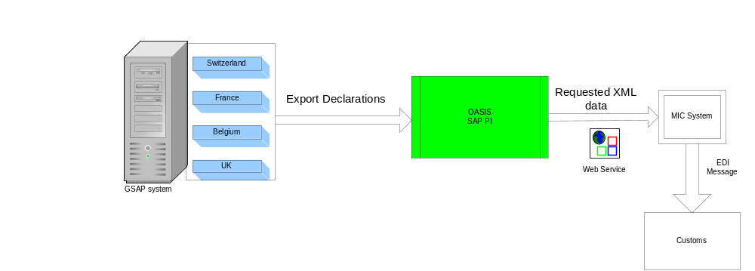

- Interfaces will be built using SAP PI technology.
- SAP PI will interact MIC by using standard SOAP adapter to call MIC using web services.

Functional Requirements

Functional Specification
:
- Whenever the export declarations are created in GSAP, data will be sent to SAP PI in XML structure by using ABAP Proxy.
- The XML received from SAP is mapped to SOAP message requested by MIC and posted to MIC by calling the web service.

Interface Process Flow Diagram

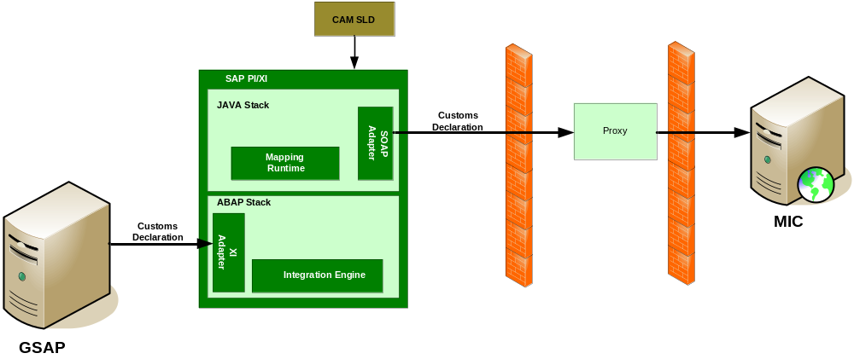

Security Requirements

The message will be sent to MIC via SOAP over HTTPS hence security will be taken care.

Interface Requirements

System Details and Direction

Receiving System: MIC system

 | Development | Test | Production
Target URL | https://webdux63.mic-cust.com/miccustaes/services/Export | https://webdux63.mic-cust.com/miccustaes/services/Export | https://webdux63.mic-cust.com/miccustaesprod/services/Export
Password | NA | NA | NA
SSL Authentication | NA | NA | NA
Proxy Server  (Host Name) | ( 192.6.178.101 ) (Primary)  ( 192.208.44.100 ) (backup)  Port:8080 | ( 192.6.178.101 ) (Primary)  ( 192.208.44.100 ) (backup)  Port:8080 | ( 192.6.178.101 ) (Primary)  ( 192.208.44.100 ) (backup)  Port:8080
User | h515704 | h515704 | h515704
Password | Enabled | Enabled | Enabled
Location/Site
System Role | Message Destination

Sending System: GSAP

 | Development | Integration | UAT | QAT | Production
System ID | E1B | I1B | U1B | Q1B | P1B
Client | 010 | 010 | 010 | 010 | 010
Appserver (Hostname) | sape1b.eame.syngenta.org | sapi1b.eame.syngenta.org | sapu1bci.eame.syngenta.org | sapq1b.cp.chbs | sapp1b.eame.syngenta.org
System Number | 06 | 07 | 00 | 01 | 00
Gateway | sapgw06 | sapgw07 | sapgw00 | sapgw01 | sapgw00
Location / Site | Basel | Basel | Basel | Basel | Basel
User
Password
System Role | Message Source

Direction:
Outbound from GSAP: customs declaration notification messages.

Transaction Volume

50 Messages per day for all countries.

Frequency and Timing

Real time processing

Initiating Process / Transaction / Program

Each of the interface flows are triggered by the report from SAP which will trigger an ABAP Proxy to generate XML data and sent to SAP PI.

The ABAP Proxies are created as follows:
The user will trigger the messages using Z transaction.Immediately after each ABAP Proxy is received successfully in PI; the data is mapped to the corresponding MIC web servise.

Processing Type

The XML data generated form ABAP Proxy will be posted to MIC via web service call that happens online.

Proposed Transfer Method / Program
At the source end the data is received in the form of ABAP Proxy. At the destination end the data is sent using web service calls.

Target / Source Data Layout
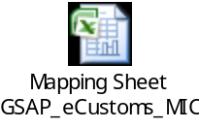

Mapping SAP fields to Source / Target
Please see section 6.7

Network Integration
The messages from PI need to be routed through Proxy server configured for PI systems.

Reporting and Monitoring

Error Handling

If message failed between R/3 & PI:

There are 3 instances when message from R/3 to PI will fail;
- When ABAP Proxy method failed to execute:
  - In this case a red traffic light will be set against such deliveries in the ALV grid report. User can try to send this message again, if it still fails (happens very rarely) user needs to raise a helpdesk case for SAP SD Support team.
- ABAP Proxy messages will fail to get transmitted when messages are stuck in queue.
  - In this scenario the ABAP proxy message will be generated and will be hung in the RFC queue. Such messages can be seen in transaction SMQ2. In such cases Basis support team needs to be contacted to resolve the RFC queue issue. Once connectivity issue is resolved messages lying in the RFC queue will get transmitted automatically.
- Unexpected SAP R/3 or PI system downtime.
  - For any unexpected system downtime, business will be notified by means of service announcement. User can raise a clarify case to global SAP support or global OASIS L2 support (INF_GLOBAL2_OASIS) and all the tickets will be closed as per standard support model.

If message failed between PI & MIC.

There are 2 instances when message from PI to MIC will fail;
- When validation in MIC failed:
  - In this case MIC will inform the concerned user or MIC will inform PI support team. User will have to correct the entry in MIC or correct data in SAP and resend the data.
- Message stuck in PI queue due to network or some other issue.
  - If there are any Network issues while delivering the message from PI to MIC, by default system will try to deliver the message to MIC 3 times and will deliver if the network is fine. Still if the network down, business users will be contacted immediately by support team with all the details by an email. For this, the failed messages can be resent from SAP PI once the issue is solved. There will be two possibilities for this failure. One is MIC web service is not reachable and another one is due to Syngenta network issues. For the first case, MIC should take care of the responsibility to solve this and for the second case OASIS team will work with infrastructure team to solve this. For both this cases, business will be notified immediately with all the details by an email.

If message failed between MIC & Customs system
- This is currently not handled.

SAP Requirements (if applicable)

Selection Screen Details



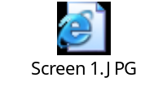
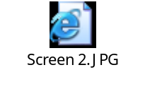

Transaction Screen Sequence (if no load module exists)
None

Post Interface Activities
None

Legacy System Extract/Load Procedure
None

Security and Authorization
Refer FRS_eCustoms.doc

Reconciliation Procedures and Audit Requirements

Approach
Not Applicable

Metrics
Not Applicable

Batch Requirements
No batch requirements from OASIS PI interface side.

Data Maintenance Requirements
None

Process and Operational Considerations

Performance
The data generated after triggering ABAP proxy will be of complex XML structure. This was considered since the MIC system requires the data as single xml file through web service call.

Backup and Archiving

No special requirements for back-up/archiving. Even the successful messages need to be archived for at least 3 months by default.

Change Management Requirements

None

Migration Requirements

None.

Reprocessing and double loading requirements

When there is Fault Message from MIC received by PI, the support team monitoring the channels will come to know this and will contact MIC support team to resolve the issue. GSAP support may be contacted if required.

Note: As the duplication of messages is not being discarding by MIC at their end, extra care should be taken before retriggering the message from PI. Please contact MIC support team and check with them before retriggering of the message.

By default behavior, the SOAP adapter will retry to deliver the message in case of fault message response from MIC for 3 times.This retry attempt will hit the web service and MIC can see these hits in their logs. PI and MIC are not able to handle the duplicate messages coming from GSAP.

Other

None.

Testing Requirements

Key Business Test Conditions

ID | Condition | Expected results | Cycle Ref.

Design Alternatives
Background
Options
Recommendation and Decision

Outstanding Issues

Issue No | Description | Assigned To | Status | Impact | Resolution

Appendix

Glossary of Terms

Term | Definition

Additional Supporting/Reference Documentation

